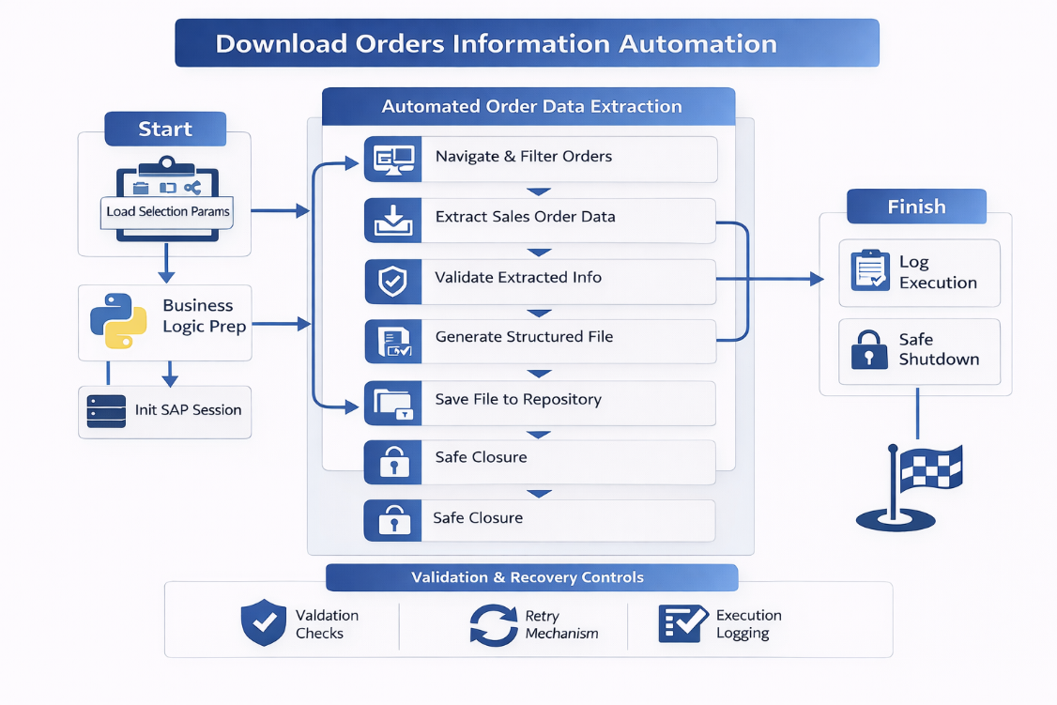
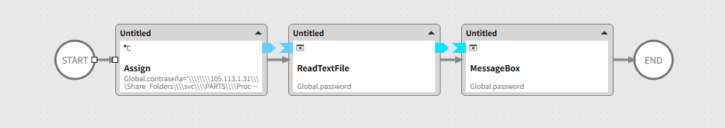
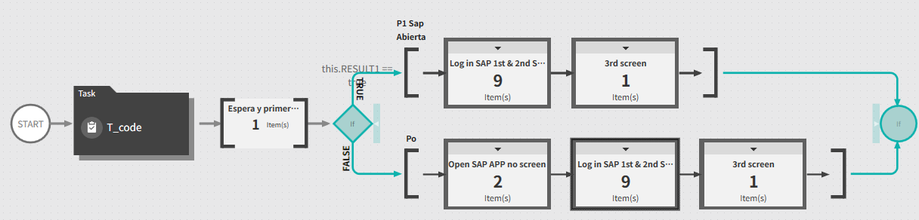
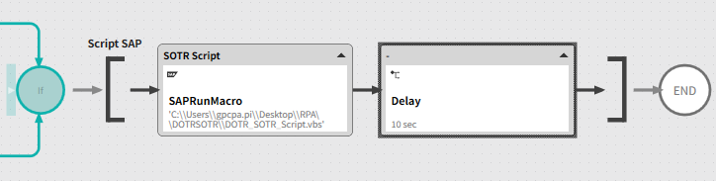

🚀 Executive Summary
Enterprise-grade RPA solution that automates the extraction, consolidation, and storage of Sales Order information from SAP, replacing a repetitive manual download process with a validated, structured, and auditable automation.
The solution ensures reliable access to up-to-date order data while reducing operational effort and dependency on manual execution.

🎯 Business Problem
The order information download process was manual and inefficient:
- Manual SAP navigation to access order data
- Repetitive execution across multiple orders or criteria
- High dependency on user availability
- Risk of incomplete or inconsistent data downloads
- No standardized file structure or naming
This caused delays, data inconsistencies, and unnecessary operational workload.

🧠 Solution Overview
A fully automated RPA solution was designed to extract Sales Order data from SAP, apply validation rules, and generate structured output files ready for analysis or downstream processes.
The automation ensures consistency, traceability, and repeatability in order data extraction.

🖼 RPA Orchestration Breakdown
- Initialization & Configuration
  - Load execution parameters (date ranges, sales org, output paths)
  - SAP session cleanup and controlled startup
- SAP Navigation
  - Navigate to Sales Order transactions
  - Apply selection criteria and filters
  - Validate screen and data readiness
- Order Data Extraction
  - Download relevant Sales Order information
  - Capture headers, line items, quantities, and statuses
  - Validate extracted data completeness
- File Generation & Storage
  - Generate standardized Excel / CSV files
  - Apply naming conventions and folder structure
- Post-Processing & Validation
  - Verify file integrity and record counts
  - Log execution results
- Safe Closure
  - Controlled SAP shutdown
  - Archive execution logs

📊 Results & Business Impact
- Faster access to order information
- Elimination of repetitive manual downloads
- Improved data consistency
- Reduced operational dependency
- Reliable input for reporting and analytics

🔍 Before vs After
Before
- Manual SAP queries
- Repetitive downloads
- Inconsistent file formats
- High user dependency
- No execution trace
After
- Automated order data extraction
- Standardized outputs
- Consistent execution
- Traceable and auditable process
- Scalable for larger volumes

🧩 Key Features
- Automated SAP Sales Order extraction
- Configurable selection parameters
- Structured file generation
- Validation checkpoints
- Execution logging and archiving

🛠 Tech Stack
- SAP GUI Scripting
- Python (data handling and validation)
- RPA Orchestration Platform
- Excel / CSV automation
- File system management

🧠 Challenges & Design Decisions
- Large data volumes → Implemented controlled extraction logic
- SAP performance variability → Defensive navigation and validation
- Data consistency risks → Validation checkpoints and record control
- Manual dependency → Fully automated execution flow

👤 My Role
- RPA Solution Architect
- Designed end-to-end order extraction automation
- Defined data structure and validation rules
- Implemented SAP GUI automation
- Ensured enterprise-grade stability

🚀 Why This Project Matters
This project shows how RPA can industrialize data extraction, turning manual SAP interactions into a reliable, scalable, and repeatable data pipeline that supports reporting, analytics, and operational decision-making.

